**Exercise 14**

*Create a Kubernetes Cluster in DigitalOcean and Deploy Cassandra*

**Prior Knowledge**

Unix Command Line Shell

YAML

Ex 4b Terraform

**Learning Objectives**

Terraform to instantiate Kubernetes in DigitalOcean

Deploy Cassandra to Kubernetes

See how Cassandra replicates

**Software Requirements**

Browser

kubectl

k9s

doctl

**Overview**

In this exercise we are going to instantiate a Kubernetes cluster in DO (using Terraform), then install a Cassandra ring onto the kubernetes cluster. Finally we will do some load-testing.

We will mainly do this from the CLI (so it can be repeated and automated), especially using declarative approaches.

**Steps**

1. Follow the separate instructions to sign up for the Github education pack and get free DigitalOcean credit. If you already have a DigitalOcean account, it should cost less than $1 to do this exercise if you don’t leave resources running.
2. On the Ubuntu VM install some extra software:  
     
   Remove the old version of kubectl  
     
   sudo apt uninstall kubectl -y

And install a newer version:

sudo snap install kubectl --classic

1. If you haven’t done Exercise 4b on Terraform please do that first!  
   (Or at least install terraform following that exercise)
2. Install k9s and doctl  
     
   wget -O - -q <https://freo.me/install-k9s> | bash

sudo snap install doctl  
sudo snap connect doctl:kube-config  
mkdir ~/.kube

1. Authenticate to Digital Ocean.  
     
   First browse to <https://cloud.digitalocean.com/account/api/tokens>   
     
   Click **Generate a new token**

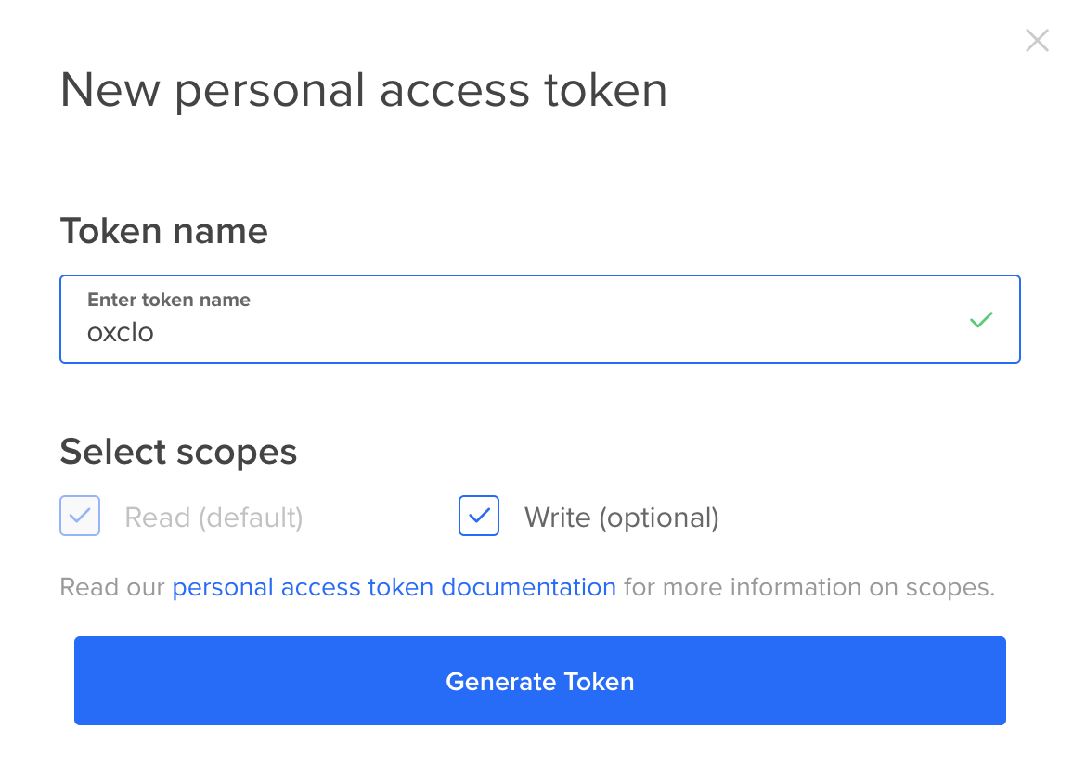

1. Copy the new token into a file so you don’t lose it.
2. Now type   
     
   doctl auth init

Please authenticate doctl for use with your DigitalOcean account. You can generate a token in the control panel at https://cloud.digitalocean.com/account/api/tokens

Enter your access token:

Paste in your token.

Validating token... OK

1. We also need to use that token in the environment so Terraform can find it:

echo “export DIGITALOCEAN_TOKEN=<put your token here>” >> ~/.bashrc  
  
source ~/.bashrc

1. Check out my git repository:  
     
   git clone https://github.com/pzfreo/clo-k8s-digital-ocean.git

cd clo-k8s-digital-ocean

1. Initialise Terraform

terraform init

1. Check the plan:  
     
   terraform plan

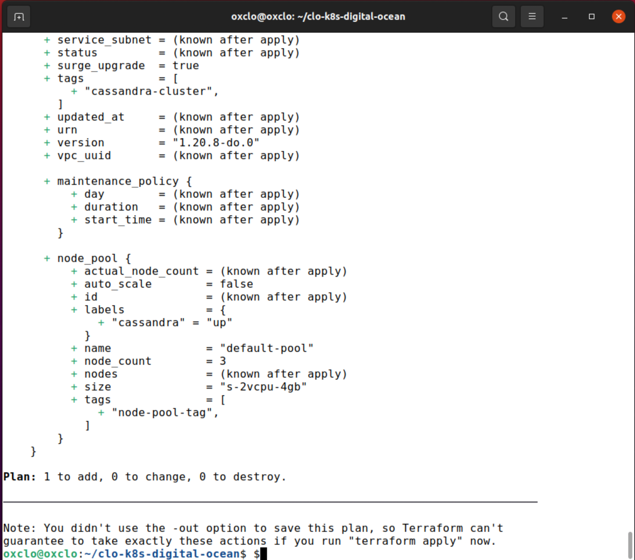

1. Bootstrap the k8s cluster in Digital Ocean:  
     
   terraform apply -auto-approve
2. You should see:  
   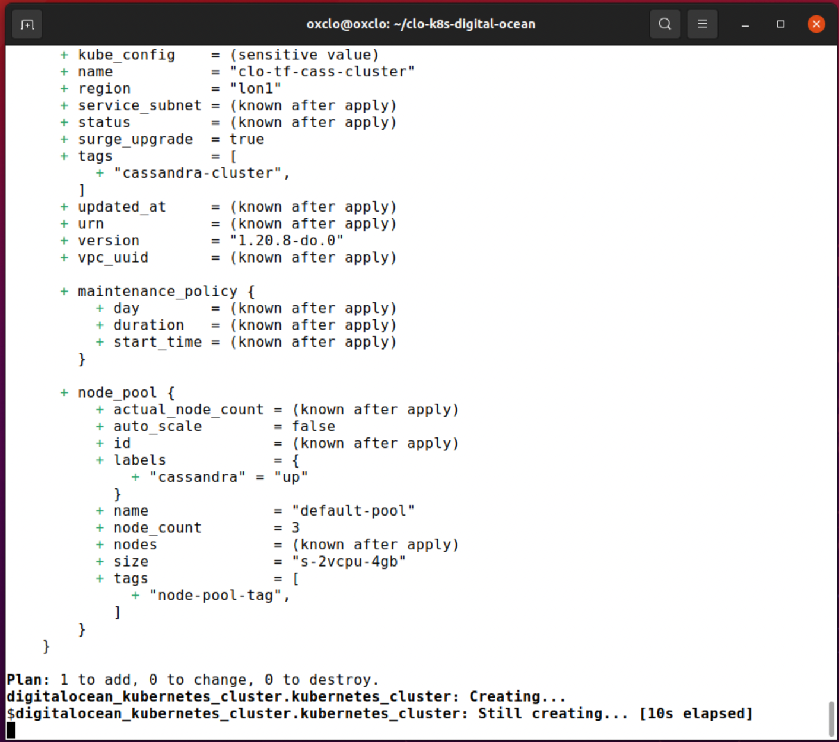
3. Go have a coffee… It normally takes ~6 minutes to start up.
4. You can also see what is happening in the Digital Ocean console.

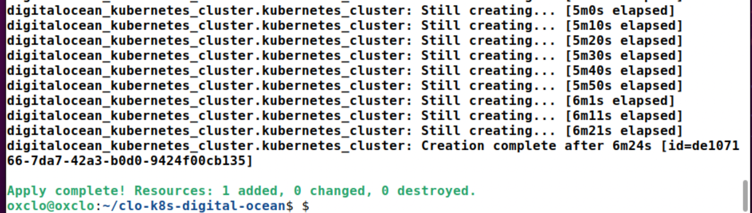

1. Once the cluster is running you need the right credentials for kubectl to connect to it. Luckily there is a cool doctl command to configure that:

doctl kubernetes cluster kubeconfig save clo-tf-cass-cluster

Notice: Adding cluster credentials to kubeconfig file found in "/home/oxclo/.kube/config"

Notice: Setting current-context to do-lon1-clo-tf-cass-cluster

1. Check it works:

kubectl cluster-info

You should see something like:  
  
Kubernetes control plane is running at https://de107166-7da7-42a3-b0d0-9424f00cb135.k8s.ondigitalocean.com

CoreDNS is running at https://de107166-7da7-42a3-b0d0-9424f00cb135.k8s.ondigitalocean.com/api/v1/namespaces/kube-system/services/kube-dns:dns/proxy

To further debug and diagnose cluster problems, use 'kubectl cluster-info dump'.

1. Try k9s:  
     
   k9s  
     
   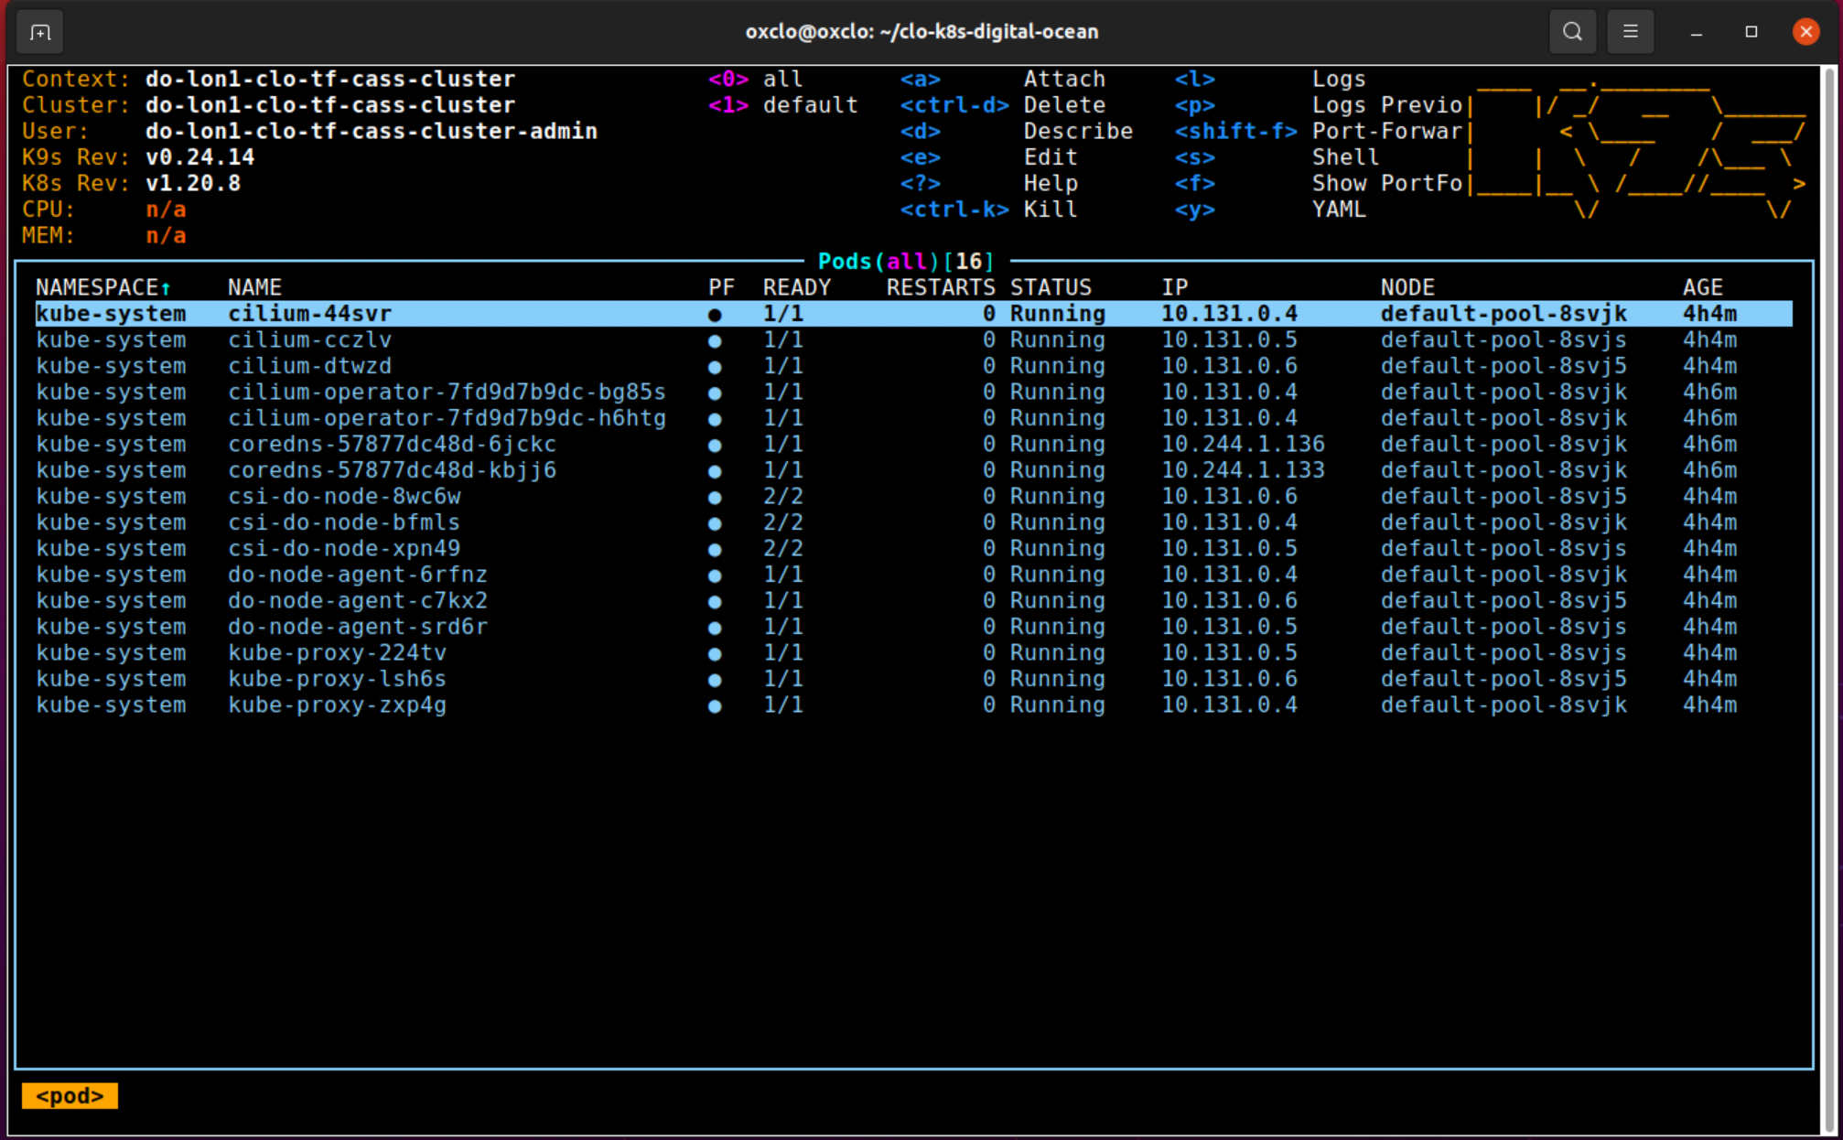
2. If your screen has no blue lines, it is only showing the default namespace. Hit 0 and it will show all namespaces.
3. Hit ‘?’ to see the help
4. We will come back to this later. For now, hit ‘:q<ENTER>’ or Ctrl-C to quit.
5. There are only two small YAML files required to get Cassandra running. They come from this webpage: <https://kubernetes.io/docs/tutorials/stateful-application/cassandra/>

They are in the ‘cass-yamls’ directory

1. Take a look at the cassandra-service.yaml:  
     
   It is really simple (for YAML!):  
   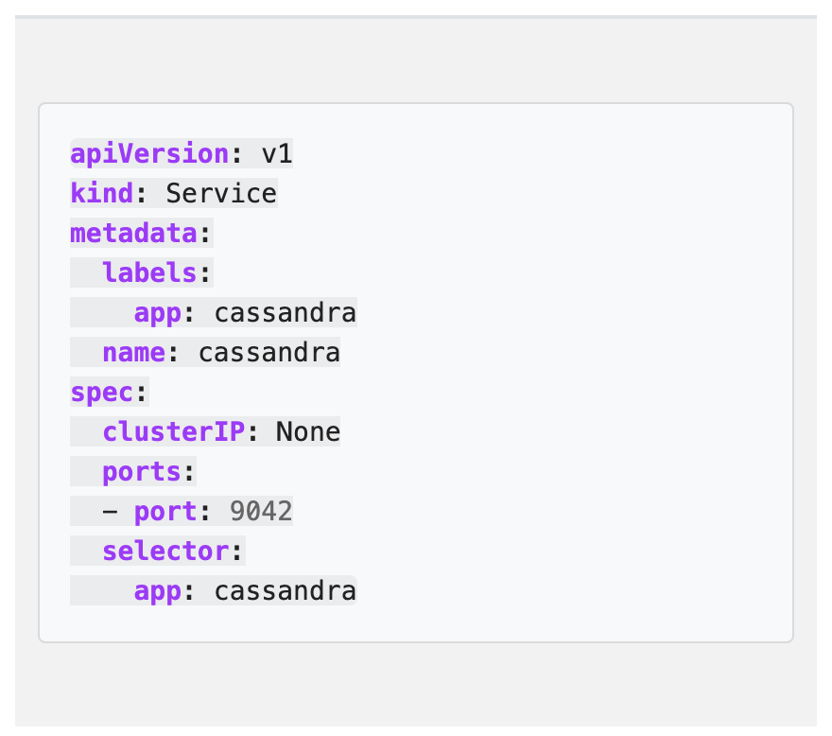
2. This is “kind of” the equivalent of EXPOSE in Docker.
3. The second file is more complex. It basically defines two things:
   1. The cassandra images and config to start a cassandra container  
        
      

(That is just the start of that bit)

b. The rest defines the storage that will be needed by these servers in a StatefulSet (<https://cloud.google.com/kubernetes-engine/docs/concepts/statefulset>)  
  
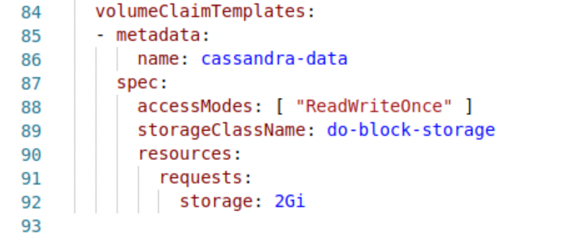

**Note:** This is not the general file from the Kubernetes homepage. Instead, this has been specifically modified to use the Digital Ocean storage backend (‘do-block-storage’)  
  
You can see what storage classes are available on Kubernetes by doing:  
  
kubectl get storageclass

NAME PROVISIONER RECLAIMPOLICY VOLUMEBINDINGMODE ALLOWVOLUMEEXPANSION AGE

do-block-storage (default) dobs.csi.digitalocean.com Delete Immediate true 5h26m

1. Let’s deploy Cassandra now:  
     
   kubectl apply -f cass-yamls/

service/cassandra created

statefulset.apps/cassandra created

1. We need to wait a bit for this to start. Basically the system is making API requests to DigitalOcean to provision disks.
2. Start k9s again. Hit ‘1’ to just show the main default namespace

You should see the containers/pods appearing and starting up:

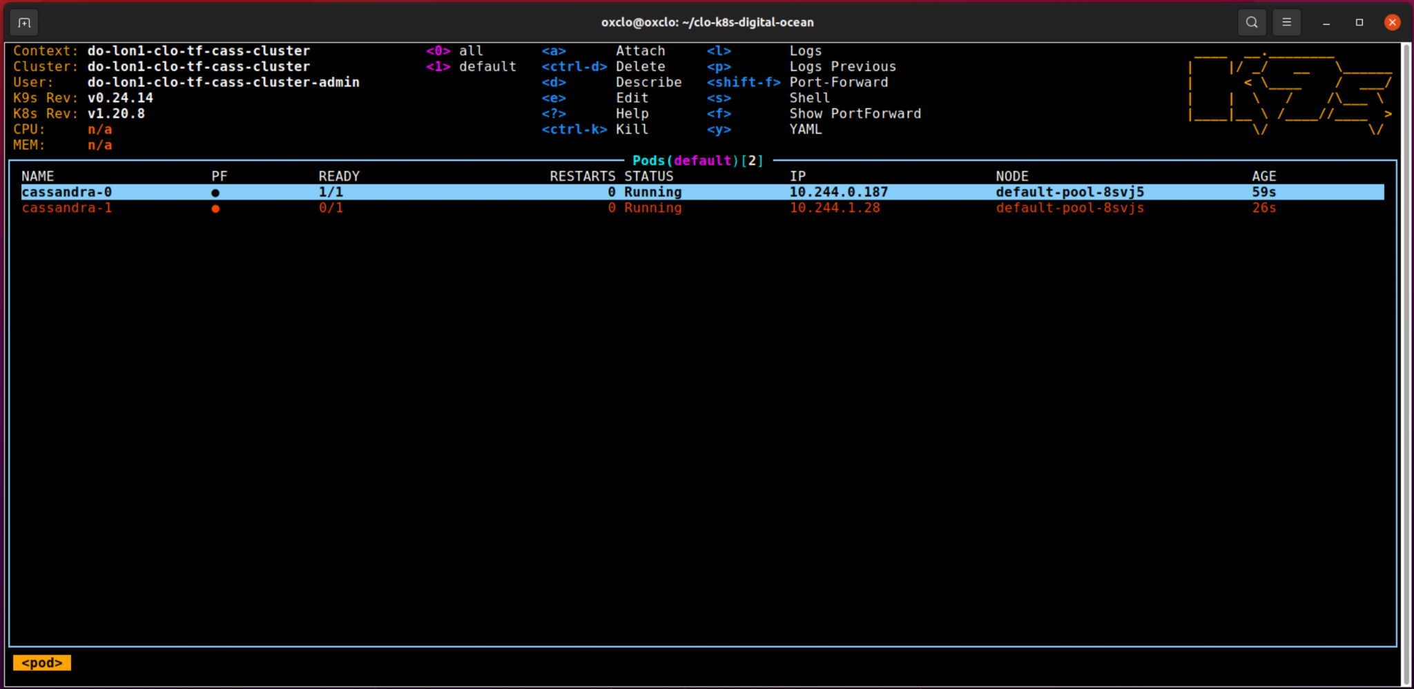

1. You can see different aspects of the Kubernetes cluster (e.g. pods, services, persistent volumes, nodes, etc) by typing ‘:’ and then the type of entity.  
     
   e.g ‘:pv<ENTER>’  
     
   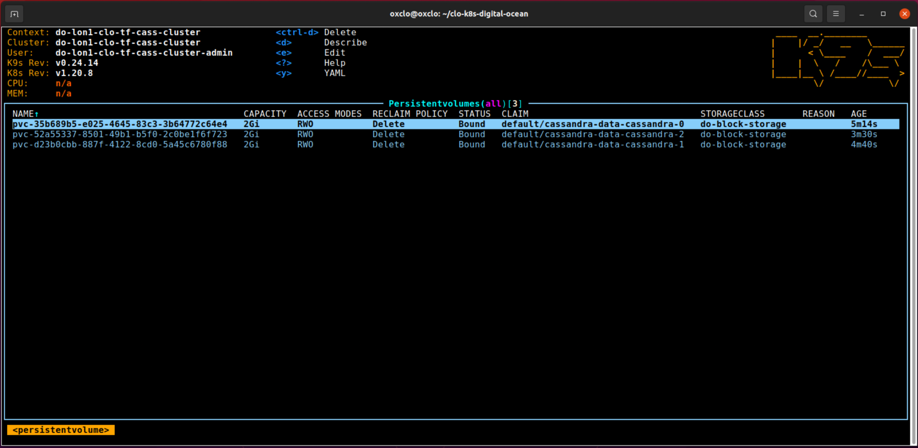
2. After about 5 minutes the cluster should be up and running:  
     
   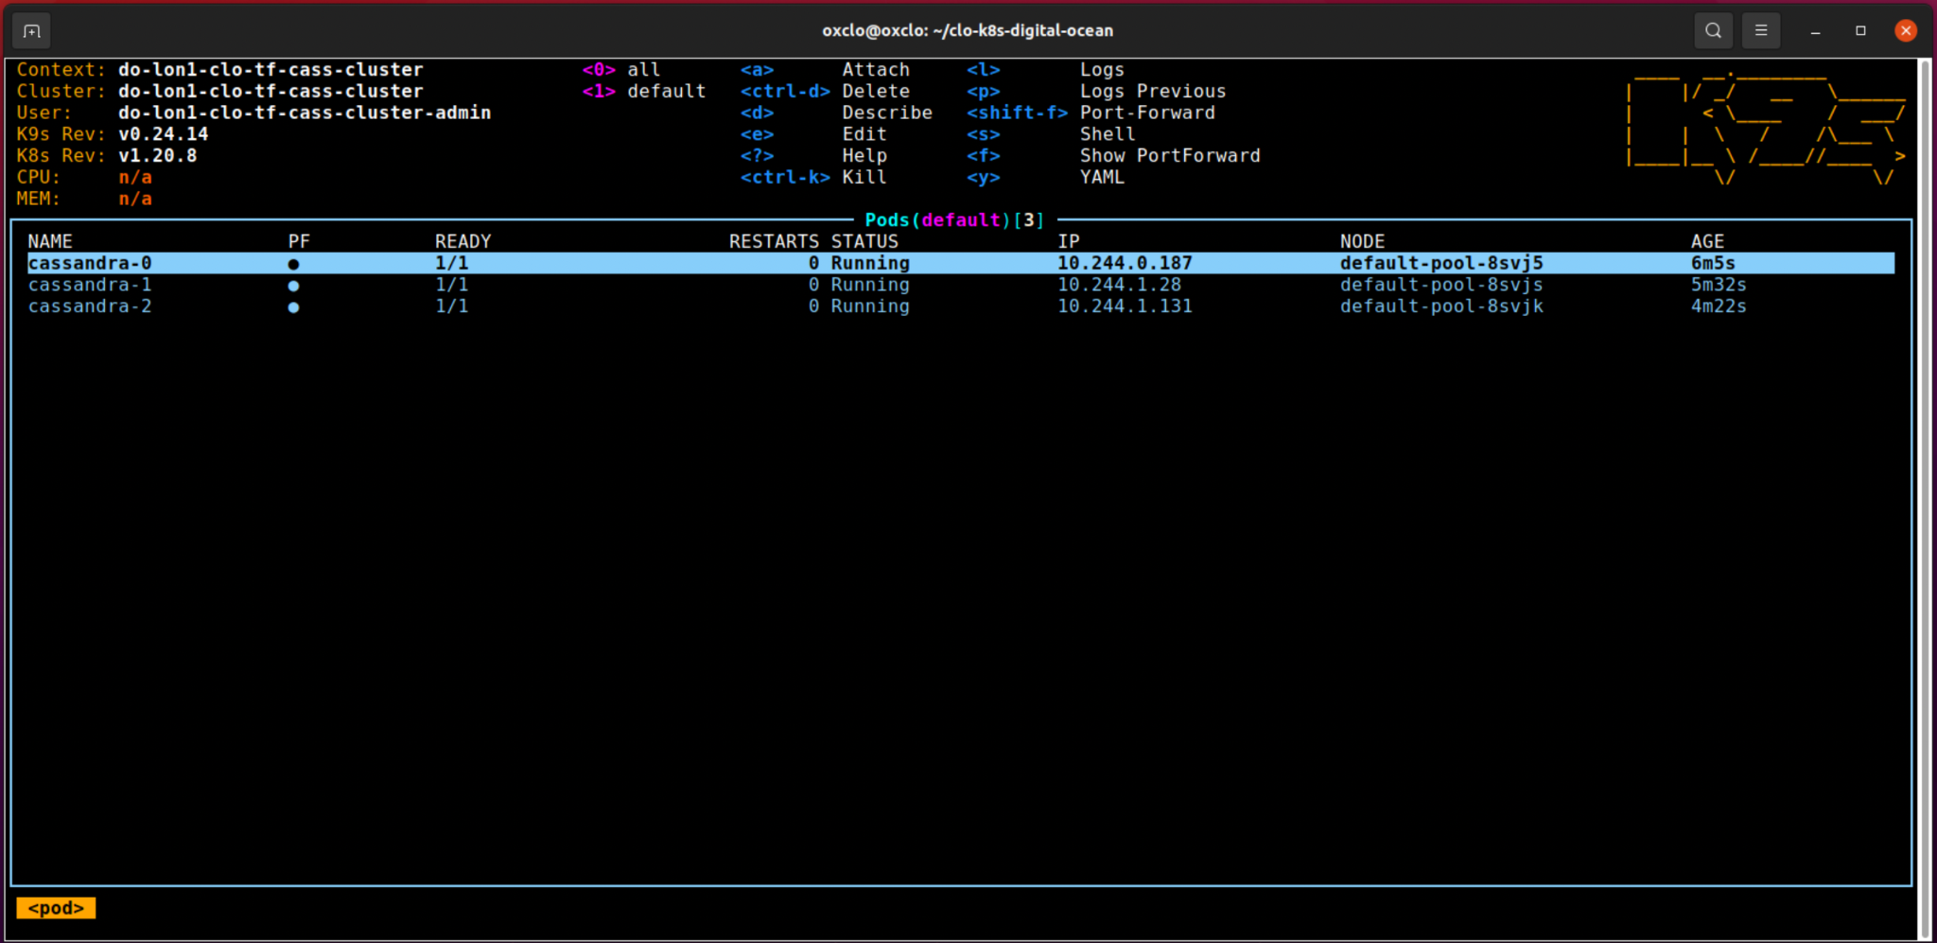
3. Quit k9s.
4. We can now execute commands in the cassandra cluster.

“kubectl exec -ti” is a bit like docker exec. This executes the command that follows -- on the cassandra-0 container instance.  
  
kubectl exec -ti cassandra-0 -- nodetool status

Datacenter: DC1-K8Demo

======================

Status=Up/Down

|/ State=Normal/Leaving/Joining/Moving

-- Address Load Tokens Owns (effective) Host ID Rack

UN 10.244.1.109 89.9 KiB 32 52.6% 70e6195b-3629-4d66-a10c-f345015cf68c Rack1-K8Demo

UN 10.244.0.153 104.55 KiB 32 73.9% 5690399f-6052-439d-b23d-e76e6c152758 Rack1-K8Demo

UN 10.244.0.73 65.81 KiB 32 73.5% c5a95d05-6891-4586-b416-db5b828b3ccf Rack1-K8Demo

1. Let’s now do a performance test from within the cluster.  
   First start a pod with some cassandra tools inside it:  
     
   kubectl apply -f [shell.yaml](https://raw.githubusercontent.com/pzfreo/ox-clo/master/code/cass-tools/shell.yaml)
2. Inside kubernetes, the networking is different to the real world. We need to know a host IP to contact the pods on:

kubectl describe svc/cassandra   
  
 Name: cassandra

Namespace: default

Labels: app=cassandra

Annotations: Selector: app=cassandra

Type: ClusterIP

IP: None

Port: <unset> 9042/TCP

TargetPort: 9042/TCP

Endpoints: **10.244.0.153**:9042,10.244.0.73:9042,10.244.1.109:9042

Session Affinity: None

Events: <none>

Choose one of the IP addresses listed as an endpoint. Make a note

(in my case 10.244.0.153)

1. Now let’s redo that test from within the cluster  
     
   kubectl exec -ti casstool -- /bin/bash

You should see something like:  
root@pool-gdbxlmdop-3oyjy:/#

From this terminal (with your IP address)  
 cassandra-stress write n=100000 -rate threads=1000 -node 10.244.0.41

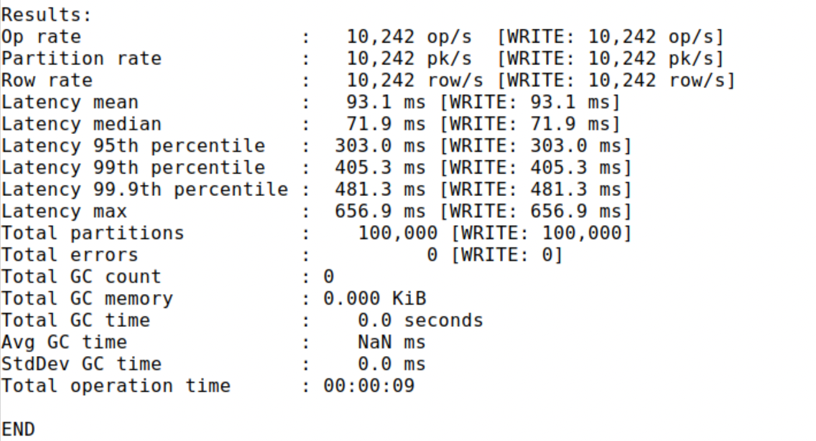

1. Do it again just to make sure its warmed up.
2. Now let’s add another node into the Kubernetes cluster.

Quit that container shell (Ctrl-D).

Edit the main.tf

Make

node_count = 4

1. Check the Terraform plan:  
     
   terraform plan

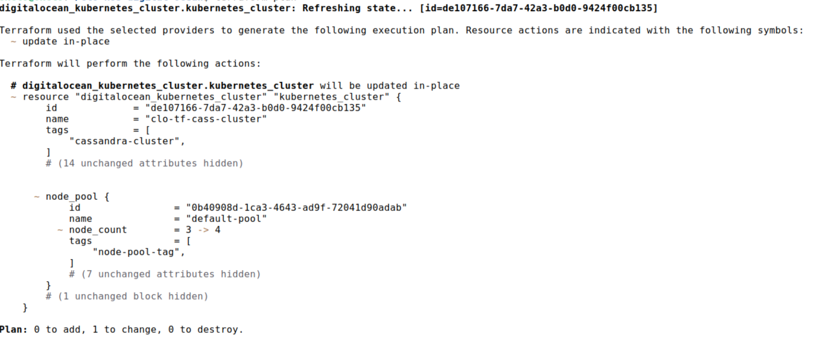

1. Now apply the change:  
     
   terraform apply -auto-approve
2. It will take a minute or so:

digitalocean_kubernetes_cluster.kubernetes_cluster: Modifications complete after 1m42s [id=de107166-7da7-42a3-b0d0-9424f00cb135]

Apply complete! Resources: 0 added, 1 changed, 0 destroyed.

1. You can see the node using:

kubectl get nodes  
NAME STATUS ROLES AGE VERSION

default-pool-8sd1s Ready <none> 63s v1.20.8

default-pool-8svj5 Ready <none> 4h48m v1.20.8

default-pool-8svjk Ready <none> 4h48m v1.20.8

default-pool-8svjs Ready <none> 4h48m v1.20.8

1. Now let’s scale cassandra on the cluster:

kubectl scale --replicas 4 statefulset/cassandra

Wait for the new instance to be live. You can watch in k9s

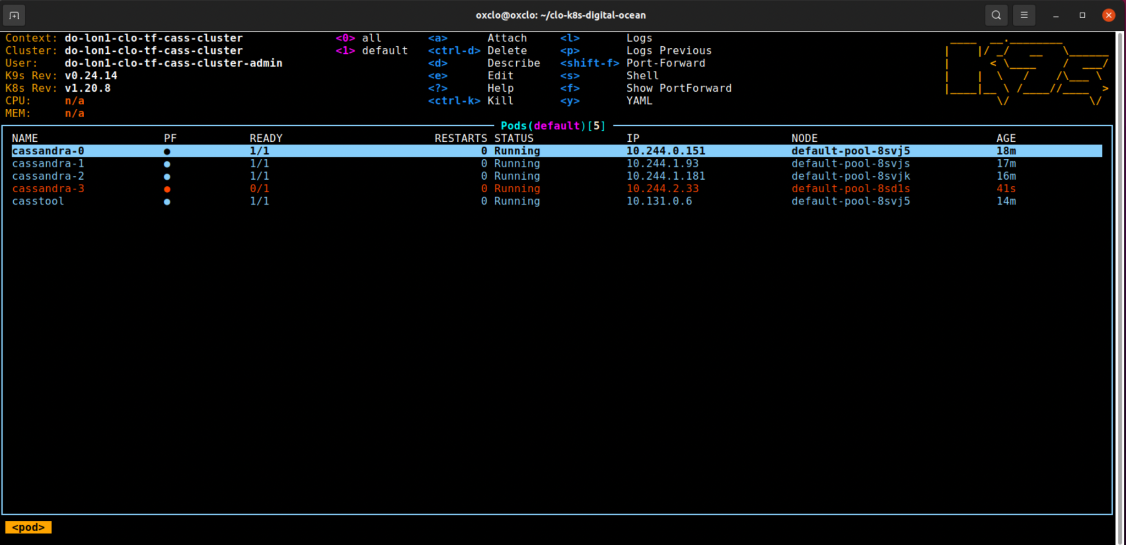

1. Now lets ask the status from Cassandra:  
   kubectl exec -ti cassandra-0 -- nodetool status

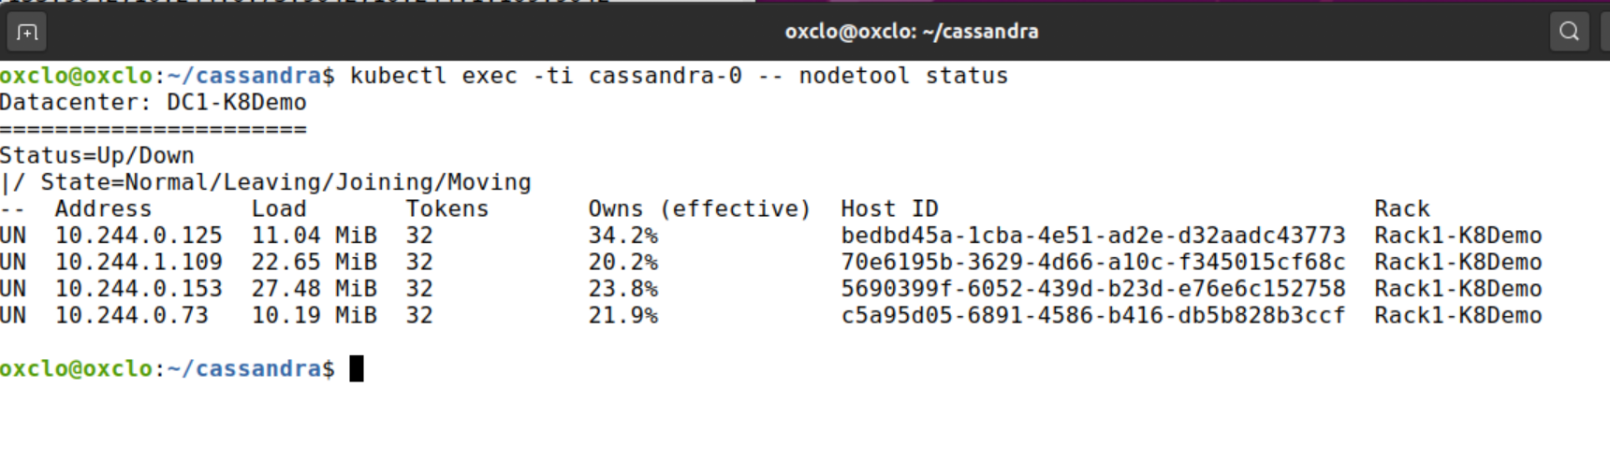

Notice how the data has already been rebalanced.

1. Rerun the stress test (Steps 29 and 30).

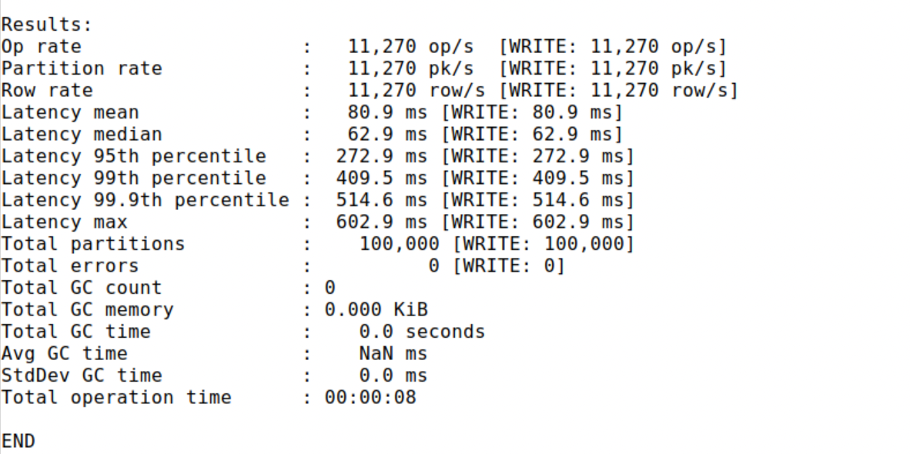

I saw a reasonable improvement in performance.

1. Sometimes the pods get bunched up on one node and not evenly spread. However, there is a cool tool called the Kubernetes Descheduler:

<https://github.com/kubernetes-sigs/descheduler>

1. Congratulations - we have deployed cassandra, scaled it, tested it and increased performance all in a kubernetes cluster.
2. Finally let’s clean up.
3. Firstly, let’s delete our cassandra cluster.   
     
   kubectl delete -f cass-yamls/
4. Delete our casstool pod:

kubectl delete pod/casstool

1. Delete the volumes / volume claims:  
     
   kubectl delete persistentvolumeclaim -l app=cassandra
2. Delete the kubernetes cluster:

terraform destroy -auto-approve

Plan: 0 to add, 0 to change, 1 to destroy.

digitalocean_kubernetes_cluster.kubernetes_cluster: Destroying... [id=de107166-7da7-42a3-b0d0-9424f00cb135]

digitalocean_kubernetes_cluster.kubernetes_cluster: Destruction complete after 0s

Destroy complete! Resources: 1 destroyed.

1. Check in the DigitalOcean Control panel for any remaining resources and just check you haven’t left anything running!
2. This lab is done! Congratulations.